Group-32

Harsh Patel – 100852669

Raquim Dockery 100660304

Christopher Fowler 100711442

Capstone Project DCOM 4100

Overview

Table of Contents

Overview 2

Protocol Used in Topology 2

NAT 3

QoS 4

# Overview

Ethoca is a global organization that specializes in identifying and resolving fraud in digital

commerce and is based in Toronto. As a result of successfully helping eCommerce

stakeholders around the world, the organization is expanding. One such expansion project

resulted in Ethoca acquiring another company called Mastermind, located in Oshawa. They

have decided to hire us to create an integrated network between these two locations.

Network Topology is designed for their requirements.

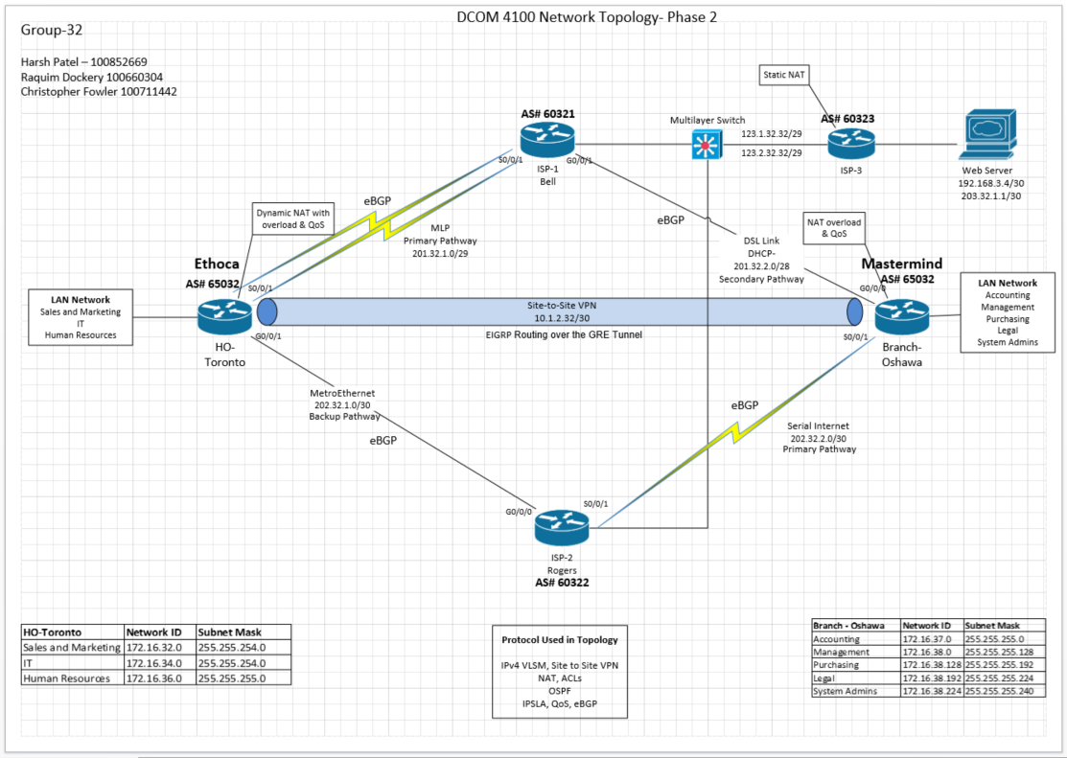

# Protocol Used in Topology

* IPv4 VLSM
* Site to Site VPN
* NAT
* ACLs
* OSPF
* IPSLA
* QoS
* eBGP

# NAT

**Network Address Translation (NAT)**

It is a technology used in computer networking to allow multiple devices within a private network to share a single public IP address for accessing resources on the Internet.

1. **On HO-Toronto** **Router**

To connect Users from the HO-Toronto LAN network to outside network **Dynamic NAT** **with overload** functionality will be used. Private IP address range Translated to 209.32.1.232/29.

1. **Branch Office- Oshawa Router**

Branch office does not have a public IP address assignment, So **PAT (known as NAT overload)** configured to Translate private IP addresses to exit interfaces to connect to the outside.

1. **On ISP-3**

**Static NAT** has been configured for Private IP of Web Server translation to Public IP

192.168.3.4 > 203.32.1.1

# QoS

**Quality of Service (QoS)**

Quality of Service (QoS) is a set of techniques and technologies used in computer networking to manage and control network traffic and ensure that specific types of data or services receive the level of priority and performance they require.

QoS Will be configured on both **HO-Toronto Router and Branch Office- Oshawa** **Router**, ensure that SSH connections to the web server located within ISP-3 able to get through their primary path even during periods of high load Quality of service.